

**Zone: Penwortham and Lostock Hall:**

**Housing sites:**

**Land off the Cawsey -** The bridge link to complete the section of the Cross Borough link road between the Cawsey and Carr Wood Way is now complete and scheduled to open in November 2019.

**The Lanes (Pickerings Farm)** – the final Masterplan has not yet been submitted, this is expected imminently, along with an outline application for housing, and a full application for part of the link road.

**Employment sites:**

|  |  |  |
| --- | --- | --- |
|  |  | **Cop Lane, Penwortham** – Tesco have retained the site and are proposing to build a store by end 2020 |
|  |  | **The Lanes (Pickerings Farm)** – the masterplan no longer includes a commercial element |

**Zone: Preston City Centre:**

**Housing sites**:

**Mosley Street, Tetrad Site** - Affordable housing scheme, progressing well, on site, 30 units completed this period

**Employment sites:**

|  |  |  |  |  |  |  |  |  |  |  |  |  |  |  |  |  |  |  |  |  |  |  |  |  |  |  |  |  |
| --- | --- | --- | --- | --- | --- | --- | --- | --- | --- | --- | --- | --- | --- | --- | --- | --- | --- | --- | --- | --- | --- | --- | --- | --- | --- | --- | --- | --- |
| |  |  |  | | --- | --- | --- | |  |  | **Shankly Hotel, city centre –** construction underway but currently stalled pending further update from the company | |  |  | **Park Hotel, East Cliff –** planning application consented, and due to start on site next calendar year following replacement of bridge | |  |  | **UClan** – continued progress on the delivery of the Masterplan, with the completion of the Engineering Innovation Centre, and start on site of the major highways/public realm scheme and student centre | |  |  | **Porsche car showroom, Docks area** – construction completed | |  |  | **Queen's Retail Park** – construction ongoing of additional retail units, now nearing completion | |  |  | **Prince's Central Buildings** – formal discussions with the health sector are to be scheduled to map out potential project scope and key milestones | |  |  | **Preston CBD** – (Hill Street/Corporation Street) marketing ongoing for office scheme and market opportunities being explored | |  |  | **Preston Cinema** – demolition of former market hall completed and programme revised with a new planning application expected Jan 2020 | |  |  | **College House, Winckley Square** -  there has been little developer activity to support occupation | | |
|  |  |
|  |  |
|  |  |
|  |  |
|  |  |
|  |  |
|  |  |
|  |  |
|  |  |

**City Deal Housing and Commercial Sites – Performance Dashboard - Progress and Issues – April to September 2019 update Appendix 2**

|  |  |  |
| --- | --- | --- |
| On track | Behind target but mitigation in place | Not on track – no mitigation |

**Updates since September 2019**

**Moss Side Test Track** - Hybrid application approved for up to 950 units the whole site, 197 unit with full planning permission

**Whittingham Hospital site –** planning application approved for 750 units

**Zone: Leyland and Cuerden**

Housing sites:

**Croston Road Heatherleigh** (south of southern) - continuing to progress well, 30 units completed this period

**Altcar Lane** – 18 units completed this period

Employment sites:

|  |  |  |
| --- | --- | --- |
|  |  | **Momentum, South Rings (Phase 2)** - Final build out of units currently underway. |
|  |  | **Samlesbury Aerospace Enterprise Zone** - Start on-site made for BAE Systems' Advanced Manufacturing Facility with preparations being made for AMRC build programme. |
|  |  | **Lancashire Central, Cuerden -** Options review completed and M65 Terminus & Sliproad design underway |
|  |  | **Moss Side Test Track** - Planning application approved November 2019 |
|  |  | **Farrington Hall Estate** - Site currently in the process of being disposed of & **Lancashire Business Park** - Planning application being prepared for a range of small industrial units |
|  |  | **Amethyst Court, South Rings** - Site currently being marketed |

**Zone: Bamber Bridge**

Housing sites:

**Wesley Street Mill** – 29 units completed this period

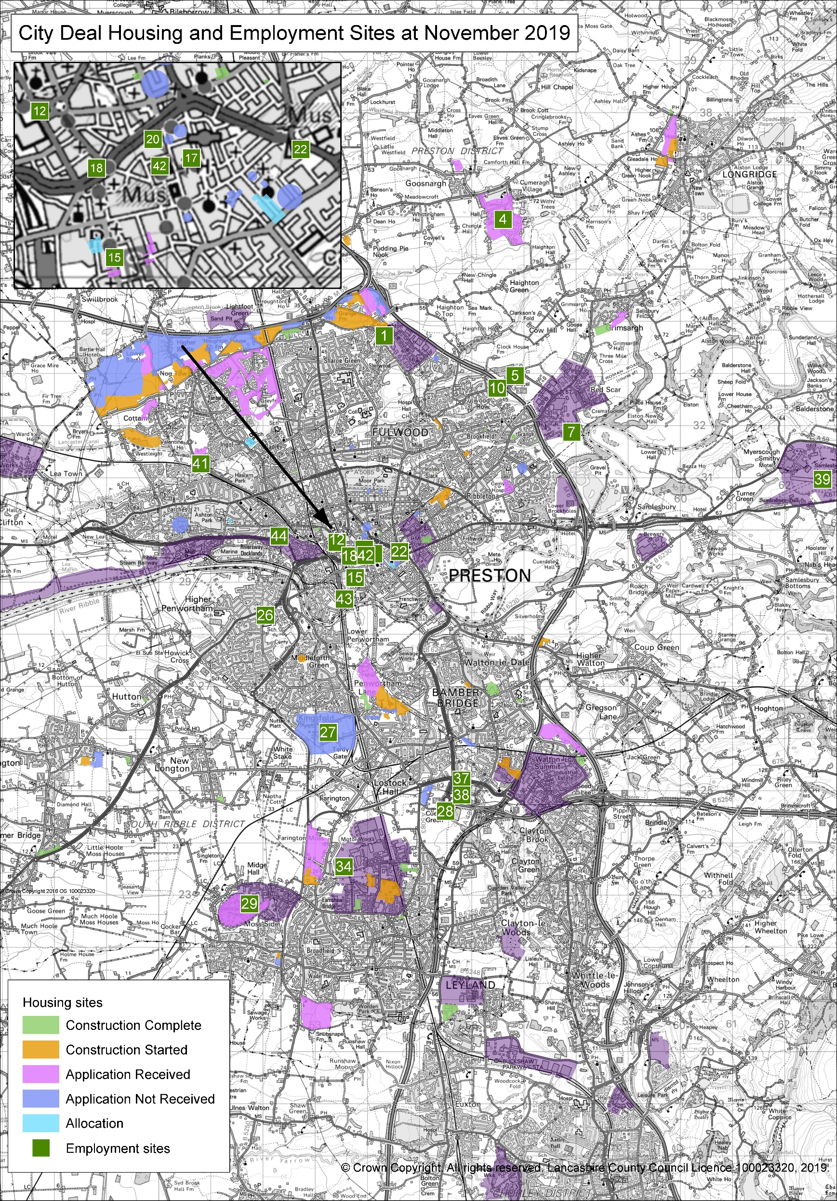

**Zone: North West Preston**

**Housing sites:**

**Hoyles Lane** - 21 units completed (6 month target exceeded)

**Land off Eastway** – (Barratt Homes site) currently progressing well, annual delivery targets have been met and exceeded in the first six month monitoring period.

**Cottam Hall Phase 3** - Initial site preparation took longer than expected, delivery delayed.

**Employment sites:**

|  |  |  |
| --- | --- | --- |
|  |  | **Eastway** – Completion of retail unit (Aldi) plus on-going construction/site preparation on a number of other sites including further retail, plus a distribution warehouse and care home |
|  |  | **Cottam Hall/Brickworks** – developer discussions ongoing with regards new potential development scheme |

**Zone: Preston East: Employment & Housing Sites**

|  |  |  |
| --- | --- | --- |
|  |  | **Bluebell Way** - Planning approval for M6 'loop' site for a car showroom, plus development plans being progressed by Barnfield/Henry Boot Developments to bring forward a large employment site in the short-medium term |
|  |  | **Red Scar** - Next phase small speculative units are currently being constructed, plus Longridge Energy Plant awaiting final planning approval. |
|  |  | **Preston East Expansion Area Land** - discussions ongoing with Homes England to bring forward the site and undertake due diligence prior to taking it to the market |
|  |  | **Whittingham site** - (Housing) Outline planning application submitted for 750 units. (Employment) Currently no commercial use in the masterplan due to a lack of market demand |